Git & GitHub

Git is an open source & free source control management (SCM)

To use Git download it for windows and install.

We are using the git bash terminal to interact with Git.

1. Open Git bash

Before using we need to configure few things:

1. Specify name and email id

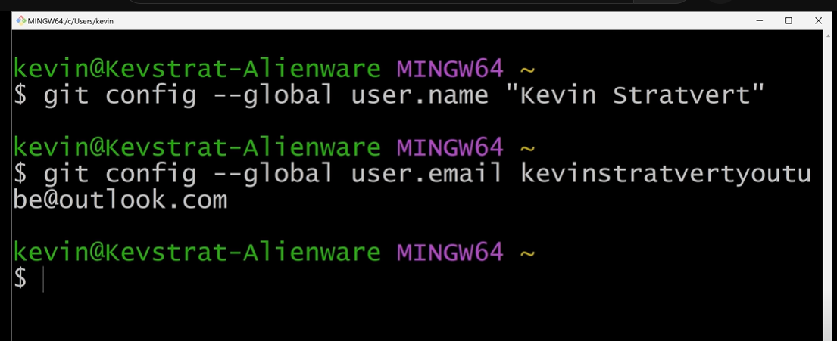

(name and email is just for example understanding)

Apurv@DESKTOP-86DOEEM MINGW64 ~ (master)

**$ git config --global user.name "Apurva "**

Apurv@DESKTOP-86DOEEM MINGW64 ~ (master)

**$ git config --global user.email Apurva@gmail.com**

Initialize a new default branch

Apurv@DESKTOP-86DOEEM MINGW64 ~ (master)

**$ git config --global init.default branch main**

**git config -h** will give all the commands and its information.

**git help config** will open a manual

to clear the commands use

clear in bash and it will give fresh git bash window

1. To track the files in from the directory:

now we have the directory with all the files

copy the path of the directory and use it in git bash using cd

**cd path**

$ cd C:/Users/Apurv/projects/Git_demo

1. To turn it into a git repository

**git init**

back in the file explorer go to view--- show------ hidden items we will see the newly created repository.

1. **git status**

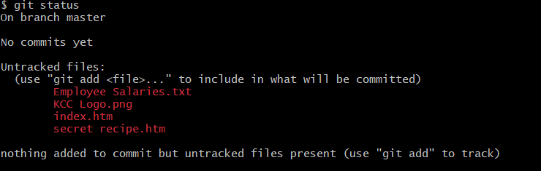

to get the status here we see we are on the default branch which is master branch and all the files are untracked.

To track a file use “git add” and then the filename

If we see index.htm file and track that we use the git commands as below:

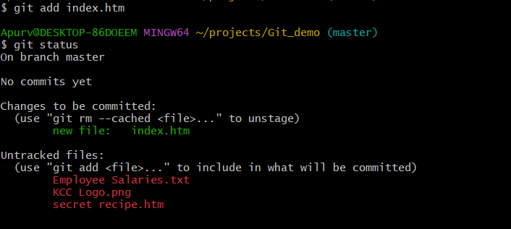

Here we see the index.htm file is being tracked but all other three files are untracked.

To untrack the file again use :

git rm - - cached filename

1. to ignore some files or folders :

create a new text document in repository without any extension and name it as “.gitignore”

write in that

And if we see the status again, then there is no .txt files we see in the git-bash

1. to track all the files:

git add - -all

git status

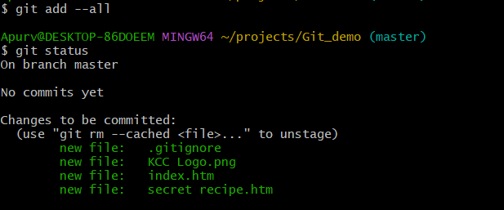

here we see all the files are bring tracked.

All these files are in the staging environment.

**What does it mean to commit?**

It means we are taking snapshot of our repository in time,

git commit -m “msg”

